Dear Data Science Team Lead,

In this initial step, the task involves preparing and exploring a dataset provided by Gala Groceries, a technology-led grocery store chain in the USA. The dataset, named "sample_sales_data.csv," is intended for use in a Python coding notebook, specifically for conducting exploratory data analysis (EDA) to understand the statistical properties, distributions, and other relevant characteristics of the data. The goal is to gain a solid understanding of the dataset's content and properties in order to formulate questions and recommendations related to Gala Groceries' supply chain challenges. This step is essential to inform the subsequent analysis and recommendations that will address the issue of optimizing stock levels for perishable grocery items.

* From the bar plot and pie plot of payment_type we can infer that the payment_type **cash, credit card, debit card** and **e-wallet** are the payment methods at Gala Groceries each having count of **2027**, **1949, 1918** and **1935** and contribution of **25.9%, 24.9%, 24.5%** and **24.7%** towards sales respectively.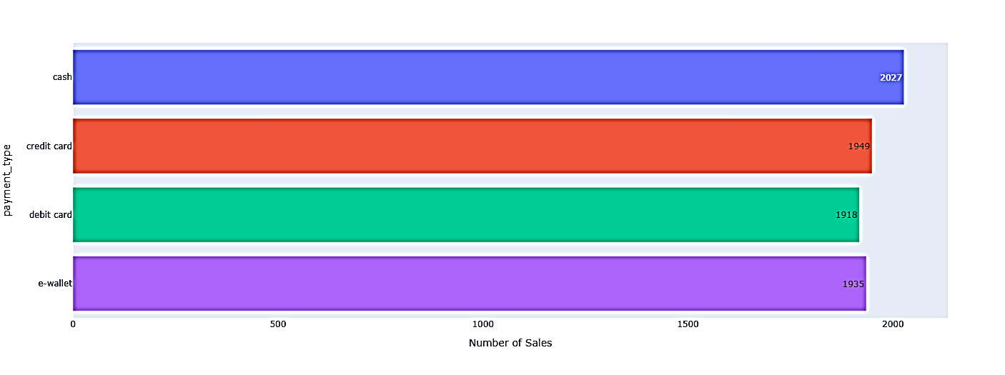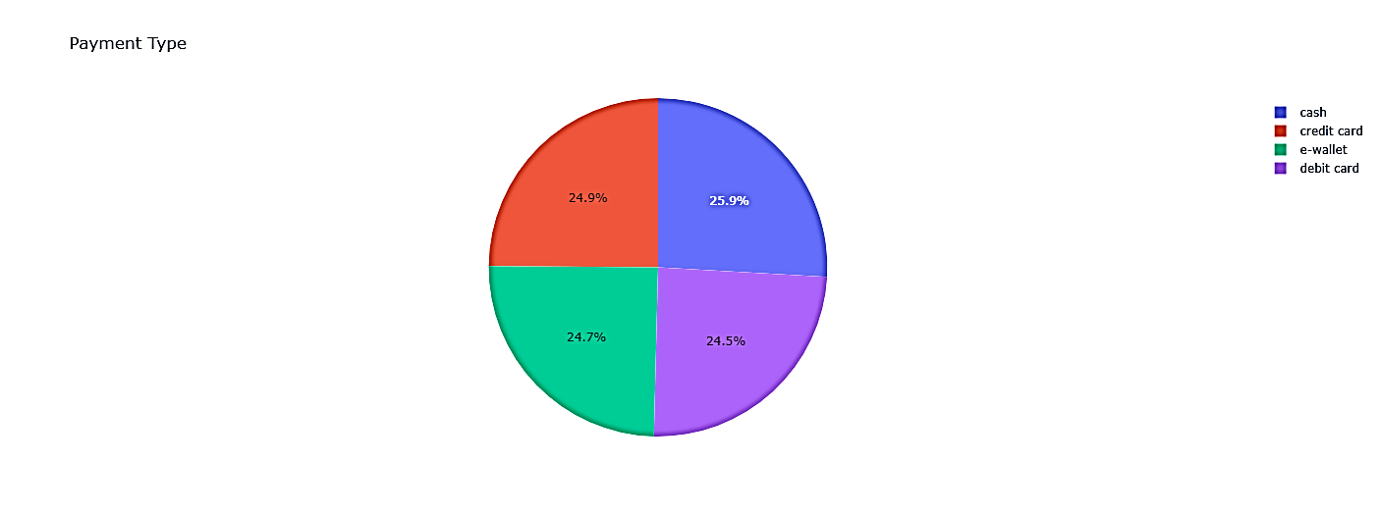
* From the bar plot of Day_of_week we can infer that **Sunday, Tuesday** and **Wednesday** are the Top – 3 days of the week at Gala Groceries each having a count of **1132, 1165** and **1169** and contribution of **14.5%**, **14.9%** and **14.9%** towards sales respectively.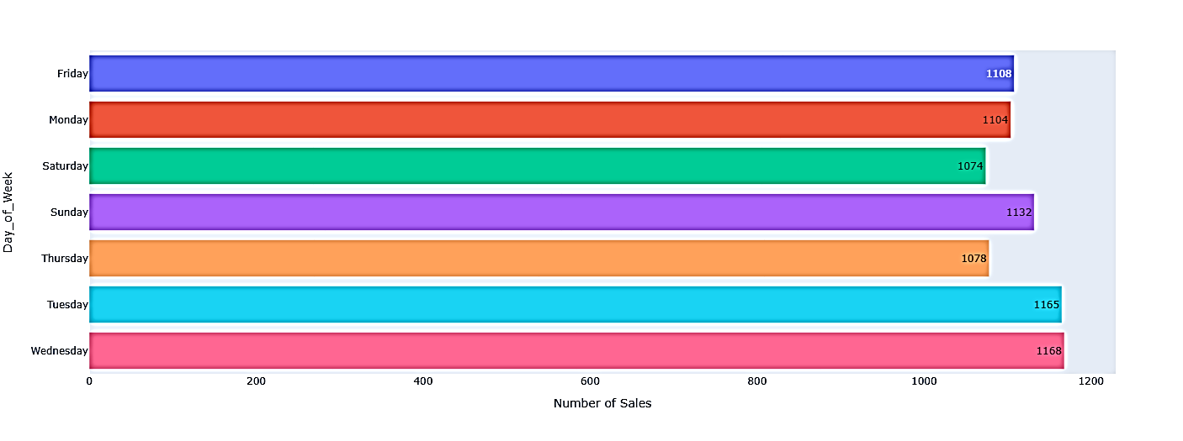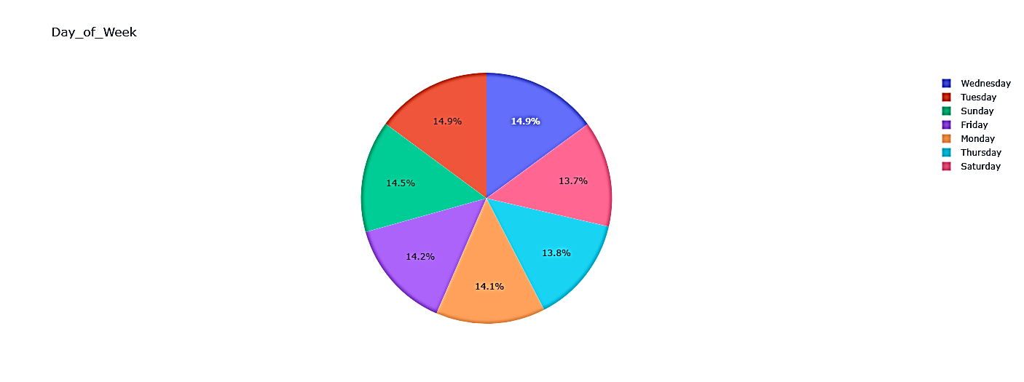
* From the bar plot and pie plot of hour of day we can infer that during the hours from **11 AM to 12 PM, 16PM to 17PM** and **18PM to 19PM**  are the Top – 3 timeslots at Gala Groceries each having a count of **738, 730**  and **727** and contribution of **9.43%, 9.32%**  and **9.29%** towards sales respectively.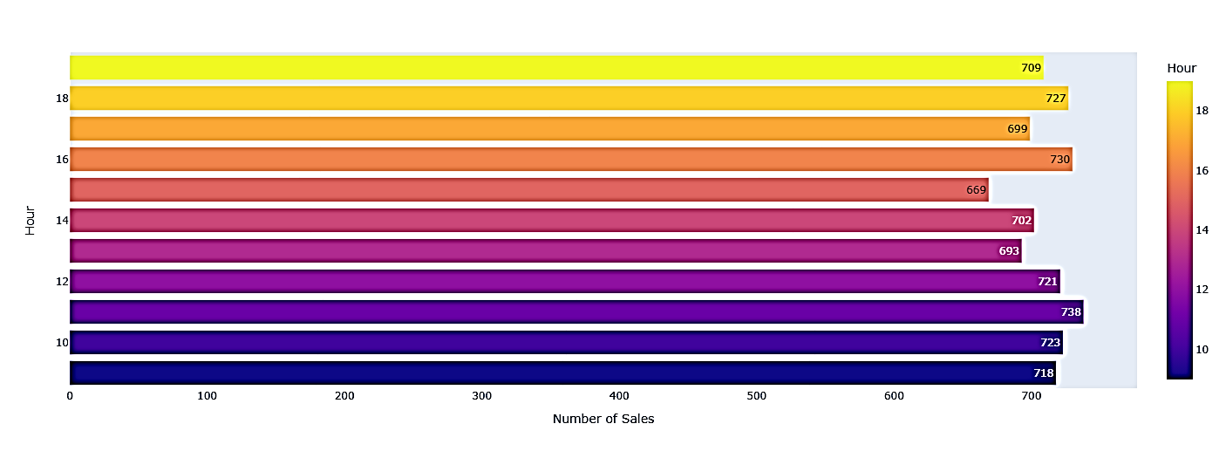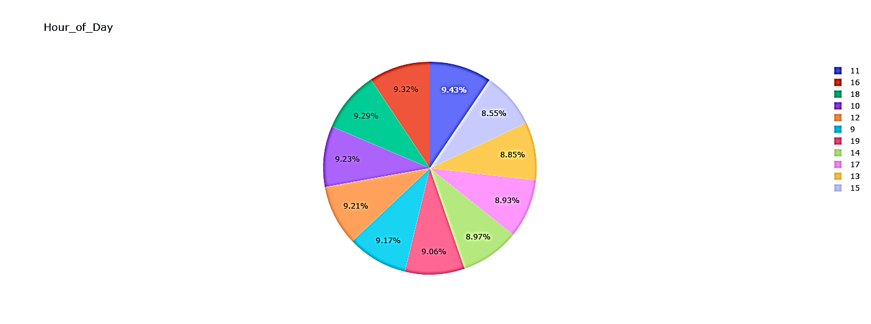
* From the bar plot and pie plot of customer_type we can infer that the customer_type **non-member, premium** and **standard** are the Top - 3 regular customers of Gala Groceries each having count of **1601**, **1590** and **1595** and contribution of **20.4%, 20.4%** and **20.3%** towards sales respectively.

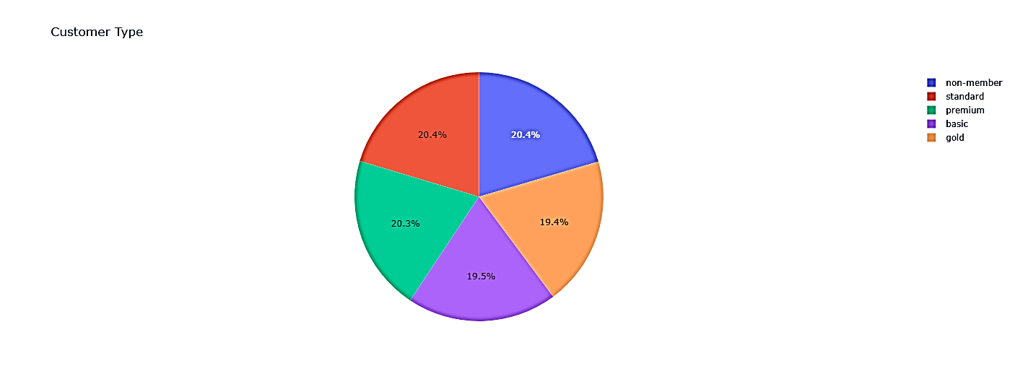

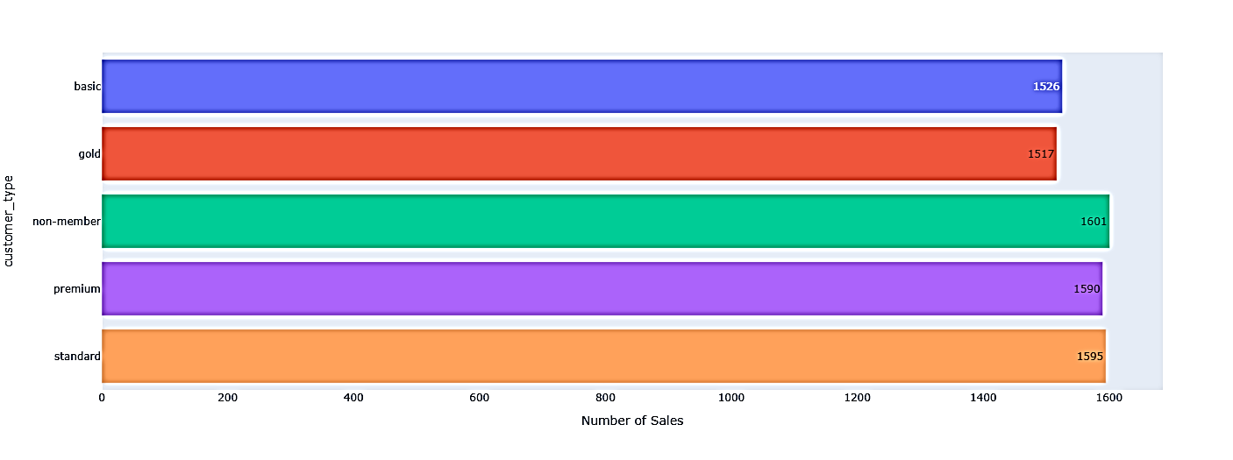

* From the correlation plot we can infer that the **unit_price** has an impact score of **0.79** on the **total.** So, to increase the profit the Gala stores can increase unit_price of individual items where possible and feasible.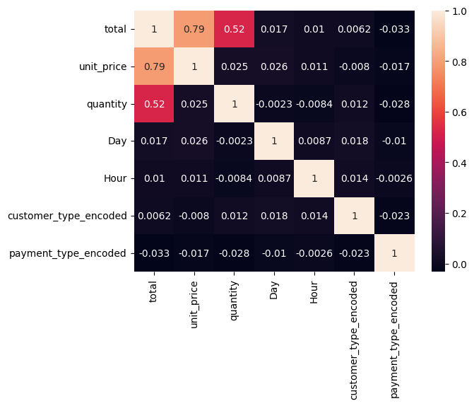
* From the scatter plot we can infer that as unit_price increase the total sales increases.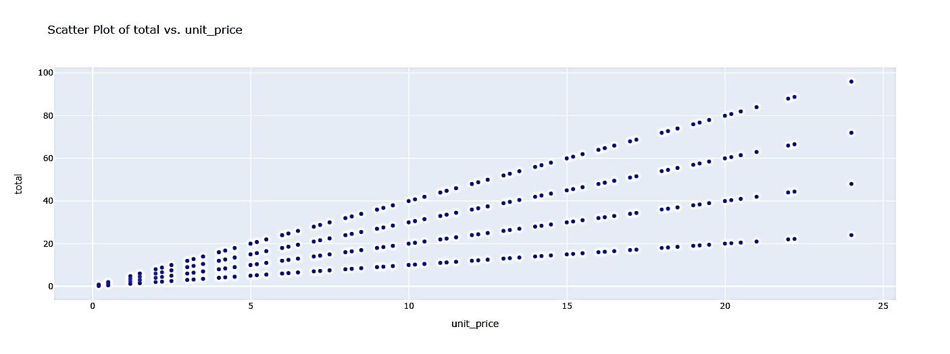
* **Fruits, Vegetables, Packaged foods, Baked goods, Canned Foods and Refrigerated items** are the type of Groceries that contribute to almost more than 5% to the sales at Gala Groceries. So, unit price of items belonging to such type of Groceries can be increased.
* Groceries that belong to type **Spices and Herbs, Pets, Personal Care** and **Condiments and Sauces** have a very low contribution below 3% to the sales at Gala Groceries and prices of such items must be increased with extreme care or discounts on such items must be increased.
* Since, the dataset is from March month of 2022 year and its almost Summer in most parts of USA so the Gala Groceries can opt for **cold beverages, refrigerated foods** and other **summer skin care and sun tan prevention** products for increasing their profits.

Best regards,

ADVAIT GURUNATH CHAVAN